Vincent Ryan

6/9/2024

Module 2.3

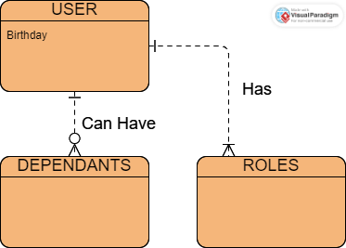

Here is a screencap of some JSON data to represent this structure. This file is on GitHub.

{

"Birthday": "date",

"Roles": {

"Role1": "Role1",

"Role2": "Role2"

},

"Dependents": {}

}